SESSION 2011

UE12 – Anglais appliqué aux affaires
Durée de l’épreuve : 3 heures - coefficient : 1

Matériel autorisé :

aucun matériel (agendas, calculatrices, traductrices) ni dictionnaire n’est autorisé.
Le sujet comporte 6 pages numérotées de 1/5 à 5/5.

Document 1
The Global Benefits of Biofuels
The Globalist ׀ Thursday, June 15, 2006

Biofuels have the potential to truly benefit not only the environment, but developing nations as well.
Of the world’s 47 poorest countries — 38 are net oil importers and 25 of these import all of their oil. Yet many of these countries have substantial agricultural bases and are well-positioned to grow highly productive energy crops.
The World Bank reports that biofuel industries require about 100 times more workers per unit of energy produced than the fossil fuel industry. The ethanol industry is credited with providing more than 200,000 jobs in the United States and half a million direct jobs in Brazil.
Between 1975 and 1987, ethanol saved Brazil $10.4 billion in foreign exchange while costing the government $9 billion in subsidies. Even with subsidies, the economic savings with biofuels from avoided oil imports can be considerable and this investment paid off even more in subsequent years. Studies show that from 1976-2004, Brazil’s ethanol production substituted for oil imports worth $60.7 billion.
In Southeast Asia, Thailand, eager to reduce the cost of oil imports while supporting domestic sugar and cassava growers, has mandated an ambitious 10 % ethanol mix in gasoline starting in 2007.
(abridged)

Document 2
Why Biofuels Help Push Up World Food Prices
TIME ׀ by Bryan Walsh Monday, Feb. 14, 2010

The world is in the grip of a full-blown food crisis. According to the U.N., world food prices hit a record high in January, meaning food is now more expensive than it has ever been in real terms since the U.N. first began tracking the numbers in 1990. Grains, in particular, are more expensive than ever, with corn prices up 53% in 2010, wheat up 47% and rice now at its highest level in more than two years. At a time when much of the global economy is still struggling to bounce back from the crisis of the past few years, high food prices could push millions back into poverty and cause millions more to go hungry. “The impact is really being felt, especially outside the U.S.,” says Marie Brill, the senior policy analyst at the antipoverty NGO Action Aid USA.
Less clear is what’s actually behind the spike in food prices. Bad weather plays a major role. Rising demand for food — especially meat, whose production requires lots of grain and water — in the richer parts of the developing world is straining supplies. And then there’s ethanol, the production of which sucks up grain and cropland that could be used for food. In America, 40% of the corn crop is currently diverted to make fuel for cars. “Ethanol uses 4.9 billion bushels of corn in the U.S.,” says Lester Brown, president of the Earth Policy Institute, an environmental think tank. “That’s enough grain to feed 350 million people.”
Princeton researcher Tim Searchinger, in a column last week in The Washington Post, argued that biofuels are contributing to the food crisis. He noted that biofuels — both corn-based ethanol in the U.S. and biodiesel, which depends on palm oil, elsewhere — now consume more than 6.5% of the world's grain and 8% of its vegetable oil. That’s up from 2% and virtually nothing in 2004. In a tight world food market, tightened by bad weather, that diversion of grain and oil makes a difference for food prices, especially in developing countries where a rise in the price of staples is passed directly to consumers.
The world will have 219,000 more mouths to feed tomorrow, and another 219,000 the next day. We’d be wise to use our food for food, not for fuel.
(abridged)
Document 3
Are biofuels part of the solution to global warming, or are they a new problem?
The Guardian ׀ by Judith Kneen, Tuesday, July 15, 2008

Are biofuels the promised wonderfuel, or a global disaster? They were embraced enthusiastically by western governments looking for a viable alternative to fossil fuels. Companies have ploughed headlong into turning land over to biofuel crops. The problem is that land once farmed to feed people now feeds our cars, leading to food shortages and soaring food prices.
Biofuels are a worldwide commodity: sugar cane and maize from the Americas; biodiesel, rapeseed and sugar beet from Europe; palm oil from south-east Asia.
The UK, like other governments, is taking biofuels very seriously. The introduction of the Renewable Transport Fuel Obligation (RTFO) in April means that petrol and diesel should now contain at least 2.5% biofuel, rising to 5% by 2010. The US, with a view to reducing its dependence on other oil-producing countries, has a target of replacing 75% of oil imports with biofuel by 2025.
The world leader in biofuel motoring is Brazil, where all the cars run on ethanol or an ethanol mix.
Biofuels are theoretically carbon neutral, as the carbon released by burning them is balanced by the carbon absorbed by plant growth. However, there is considerable alarm about the sudden rise in biofuel production, including the environmental costs of land clearance for growing biofuel crops. The overriding concern, however, is that using land normally used for food production has led to food shortages and high food prices. A recent World Bank report estimates that prices have soared by 75% − far higher than anticipated, and a rate that has forced 100 million people across the world into poverty.
(abridged)

Document 4

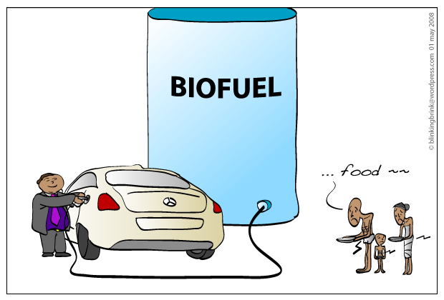
www.wordpress.com

*******************
TRAVAIL À FAIRE

Le dossier qui vous est proposé comporte 4 documents :
- Document 1 : un article du Globalist du 15 juin 2006, intitulé The Global Benefits of Biofuels
- Document 2 : un article de TIME, du 14 février 2010, intitulé Why Biofuels Help Push Up World Food Prices
- Document 3 : un article du Guardian, du 15 juillet 2008, intitulé Are biofuels part of the solution to global warming, or are they a new problem?
- Document 4 : un dessin humoristique publié le 1er mai 2008 sur le site www.wordpress.com

I - COMPRÉHENSION (10 points)
En vous appuyant sur les documents fournis, vous rédigerez en français une note de 250 mots, +/- 10 %, qui mettra en évidence les avantages et inconvénients liés à l’utilisation des biocarburants.
Vous indiquerez le nombre de mots que vous aurez utilisés.
II - EXPRESSION EN LANGUE ANGLAISE (10 points)
- To which extent can we say that the Americans are ready to reduce their oil consumption? Answer the question with a detailed analysis of the cartoon.
150 words, +/- 10 %, indicate the number of words

Cartoon by Kal, from the print edition of The Economist, June 17, 2010
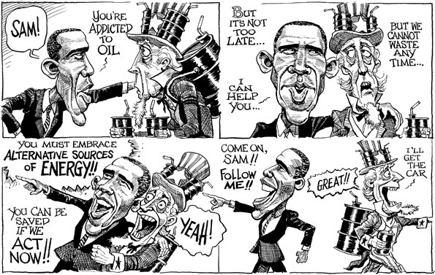
- Document professionnel à rédiger en anglais :
Vous êtes Nora White / John White et vous dirigez une entreprise de services. Dans le cadre de la politique de développement durable de votre entreprise, vous rédigez un courriel adressé à vos collaborateurs et votre personnel, leur demandant de limiter les gaspillages au sein de la société (impression des documents, utilisation des fournitures, etc.). Vous soulignez l’ensemble des avantages d’une telle pratique pour l’entreprise.
150 mots, +/- 10 %, indiquez le nombre de mots

