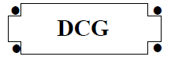

SESSION 2012

UE12 – Anglais appliqué aux affaires
Durée de l’épreuve : 3 heures - coefficient : 1

Matériel autorisé :

aucun matériel (agendas, calculatrices, traductrices) ni dictionnaire n’est autorisé.
Le sujet comporte 6 pages numérotées de 1/6 à 6/6.

What can the fashion industry do to become
Document 1
more sustainable ?
guardian.co.uk | Ilaria Pasquinelli |16 January 2012

Last year 55 kg of textiles were consumed for every man, woman and child in the UK. Until the late 80s, fashion retailers and brands would typically have two main collections a year: spring/summer and autumn/winter. Then, in the 90s things changed dramatically. Increased competition saw retailers incentivising customers to visit their stores more frequently. To do this they expanded their product ranges. The era of ‘super cheap and super fast’ took off.

Ever since, collections have become increasingly fragmented with three to five mid-season flashes in addition to the two main collections, and, in some extreme cases, there can be as many as eighteen collections a year. ‘Here today, gone tomorrow’ has become the norm. This new ‘fast fashion’ model has considerably changed the role of fashion retailers in their supply-chains, specifically how and where they buy.
Today, almost three quarters of world clothing exports are produced in developing countries with the top three exporters being Asia (54 %), South America (14 %) and Africa (6 %).

Over the course of decades, large fashion retailers have acquired significant power. The pressure on suppliers to cut costs has increased. In Bangladesh, where 80 % of the economy depends on the fashion industry, the minimum wage in 2006 was £7.16 a month. Meanwhile the price of essential commodities like rice, sugar, cooking oil and water have risen by 200 %, making it virtually impossible for workers to support their families.

Clothing is now cheaper than at any time in history. In the US, prices fell by 8.5 % in the 1997-2010 period. In the UK, between 2003 and 2007, garment prices fell by an average of 10 % and, in 2006, people bought a third more clothes than in 2002. As a direct consequence, textile production has doubled over the last thirty years.
(abridged)

The human cost of cheap clothing
Document 1
BBC World Service | James Melik | 25 July 2010

The garment industry as a whole uses developing countries to manufacture its products but, according to the British charity Action Aid, cheap fashion comes at a human price. It says the UK retail company Asda – part of the US giant Walmart – is not paying a decent wage to the workers in south Asia who manufacture its George clothing range. By a decent wage, they mean a living wage – one that covers the cost of food, clean water, healthcare, education, clothing, fuel and transport. If a living wage is the ultimate goal, the minimum wage set in Bangladesh by the government would need to double this year, next year and the year after, in order to reach the kind of level Action Aid is calling for.

Asda’s Dominic Burch says: ‘We are extremely focused on trying to improve standards in the factories we work with, but we recognise this is a very complex issue. If it was as straightforward as putting money into the supply chain then we could have solved this issue 20 or 30 years ago,’ he says. ‘It is a laudable aim but we have to find a sustainable way of doing that,’ says Mr Burch.

Like many other high street retailers, Asda joined the Ethical Trading Initiative 10 years ago. The alliance encourages retailers, brands and their suppliers to take responsibility for improving the working conditions of the people who make the products they sell. The members make a commitment to ethical trade and adopt a code of labour practice that they expect all their suppliers to work towards. Such codes address issues like wages, hours of work, health and safety and the right to join free trade unions.

Two years ago the BBC highlighted the appalling conditions in a Dhaka factory making clothes for Zara. The owner of Zara and the company’s director of corporate social responsibility flew to Bangladesh to investigate. Although it transpired that no Zara clothes were being made at that particular factory when he arrived, he agreed it was a dangerous environment.

Some unscrupulous factory managers sub-contract work, without the client’s knowledge, to other establishments. These units are often cramped, with workers sleeping in the aisles so they can take over the machines as soon as their shift begins and, quite often, they are young workers who might otherwise not be able to earn anything at all.

Earning less than $1 a day is still a better option than not earning anything at all for some people.
(adapted)

Document 1
Be an ethical pest, says Government Minister
Ethical Trading Initiative (http://www.ethicaltrade.org) | 21 October 2008

Ask more questions about where your goods are from, Trade and Development Minister Gareth Thomas said today.
Speaking to shoppers, consumer groups and chiefs of high street chains in London today, Gareth Thomas said the growing number of people wanting to shop ethically are entitled to more information about the source and production methods of their food, clothes and furniture from the places they shop.
Gareth Thomas is backing the new ‘Be an Ethical Pest’ campaign created by the Ethical Trading Initiative.
He said:
‘This is not just about trade; it’s about trade that works for local people. The public are entitled to know how ethical different shopping chains are – which ones are committed to getting their suppliers to pay a living wage, how transparent they are about their supply chains and which can be trusted never to source goods made with child labour.’
Questions to ask when out shopping:
- Do you know which country this product comes from?
- What are you doing to protect the rights of workers who are making your products?
- Do you know how much the workers making your products are paid?

Document 1
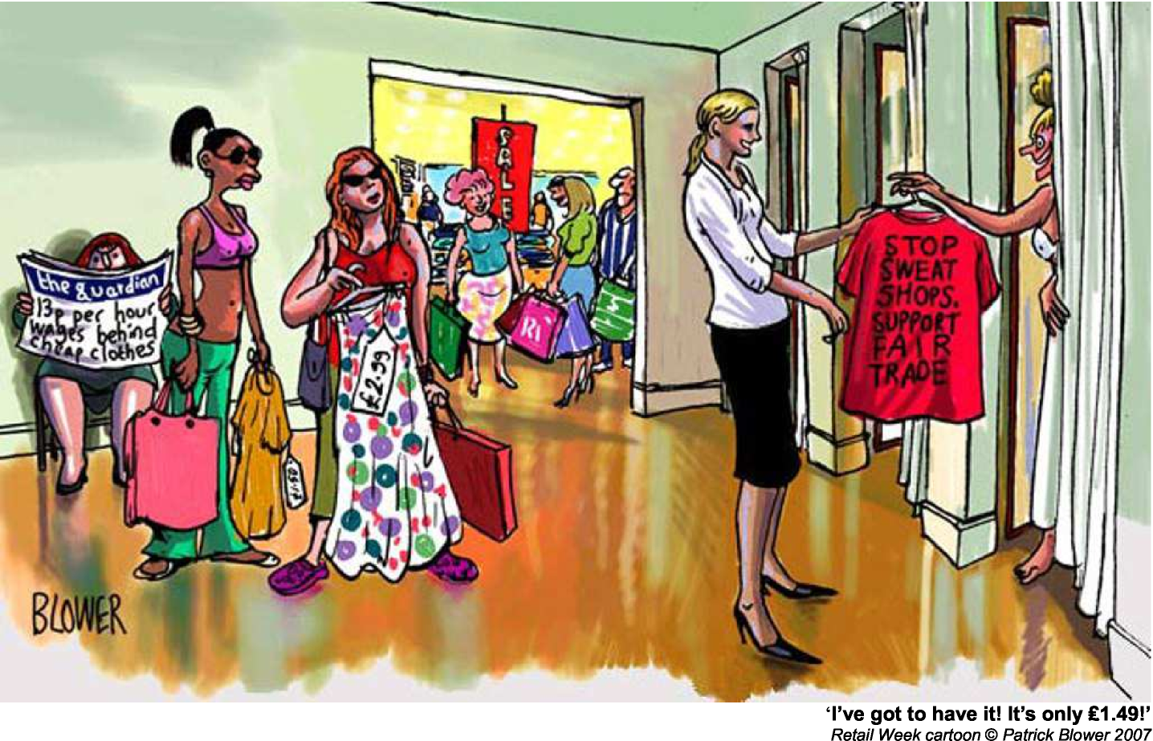
‘I’ve got to have it! It’s only 1.49!’
Retail Week cartoon © Patrick Blower 2007

*******************
TRAVAIL À FAIRE
Le dossier qui vous est proposé comporte 4 documents :

- Document 1 : un article du site guardian.co.uk du 16 janvier 2012, intitulé What can the fashion industry do to become more sustainable?
- Document 2 : un article du site BBC World Service du 25 juillet 2010, intitulé The human cost of cheap clothing
- Document 3 : un extrait du site www.ethicaltrade.org intitulé Be an ethical pest, says Government Minister et publié le 21 octobre 2008
- Document 4 : un dessin humoristique de Patrick Blower, publié en 2007

I - COMPRÉHENSION (10 points)

En vous appuyant sur les quatre documents fournis, vous rédigerez en français une note de 250 mots, +/- 10 %, qui rendra compte des informations et problématiques présentes dans ce dossier.

Vous indiquerez le nombre de mots que vous aurez utilisés.

II - EXPRESSION EN LANGUE ANGLAISE (10 points)

- Comment on document 4 and reflect on the customers’ behaviour.
150 words, +/- 10 %, indicate the number of words
- Vous êtes Sarah / James Collins. Vous appartenez à l’organisation Ethical Trading Initiative. Rédigez une lettre au dirigeant de ASDA, une chaîne de magasins célèbre, pour présenter la cause que vous soutenez et pour vous plaindre du manque d’information sur les produits textiles distribués par les magasins ASDA (origine géographique, matériaux, conditions de fabrication et de travail, impact environnemental, etc.). Vous exposerez vos arguments et vos propositions.

150 mots, +/- 10 %, indiquez le nombre de mots

