**DCG**

* ●
* ●
* ●
* ●

**SESSION 2013**

### UE 12 – ANGLAIS APPLIQUÉ AUX AFFAIRES

**Durée de l’épreuve : 3 heures – Coefficient : 1**

**Matériel autorisé : aucun matériel (agendas, calculatrices, traductrices) ni dictionnaire n’est autorisé.**

**Le sujet comporte 6 pages numérotées de 1/6 à 6/6**

**DOCUMENT 1**

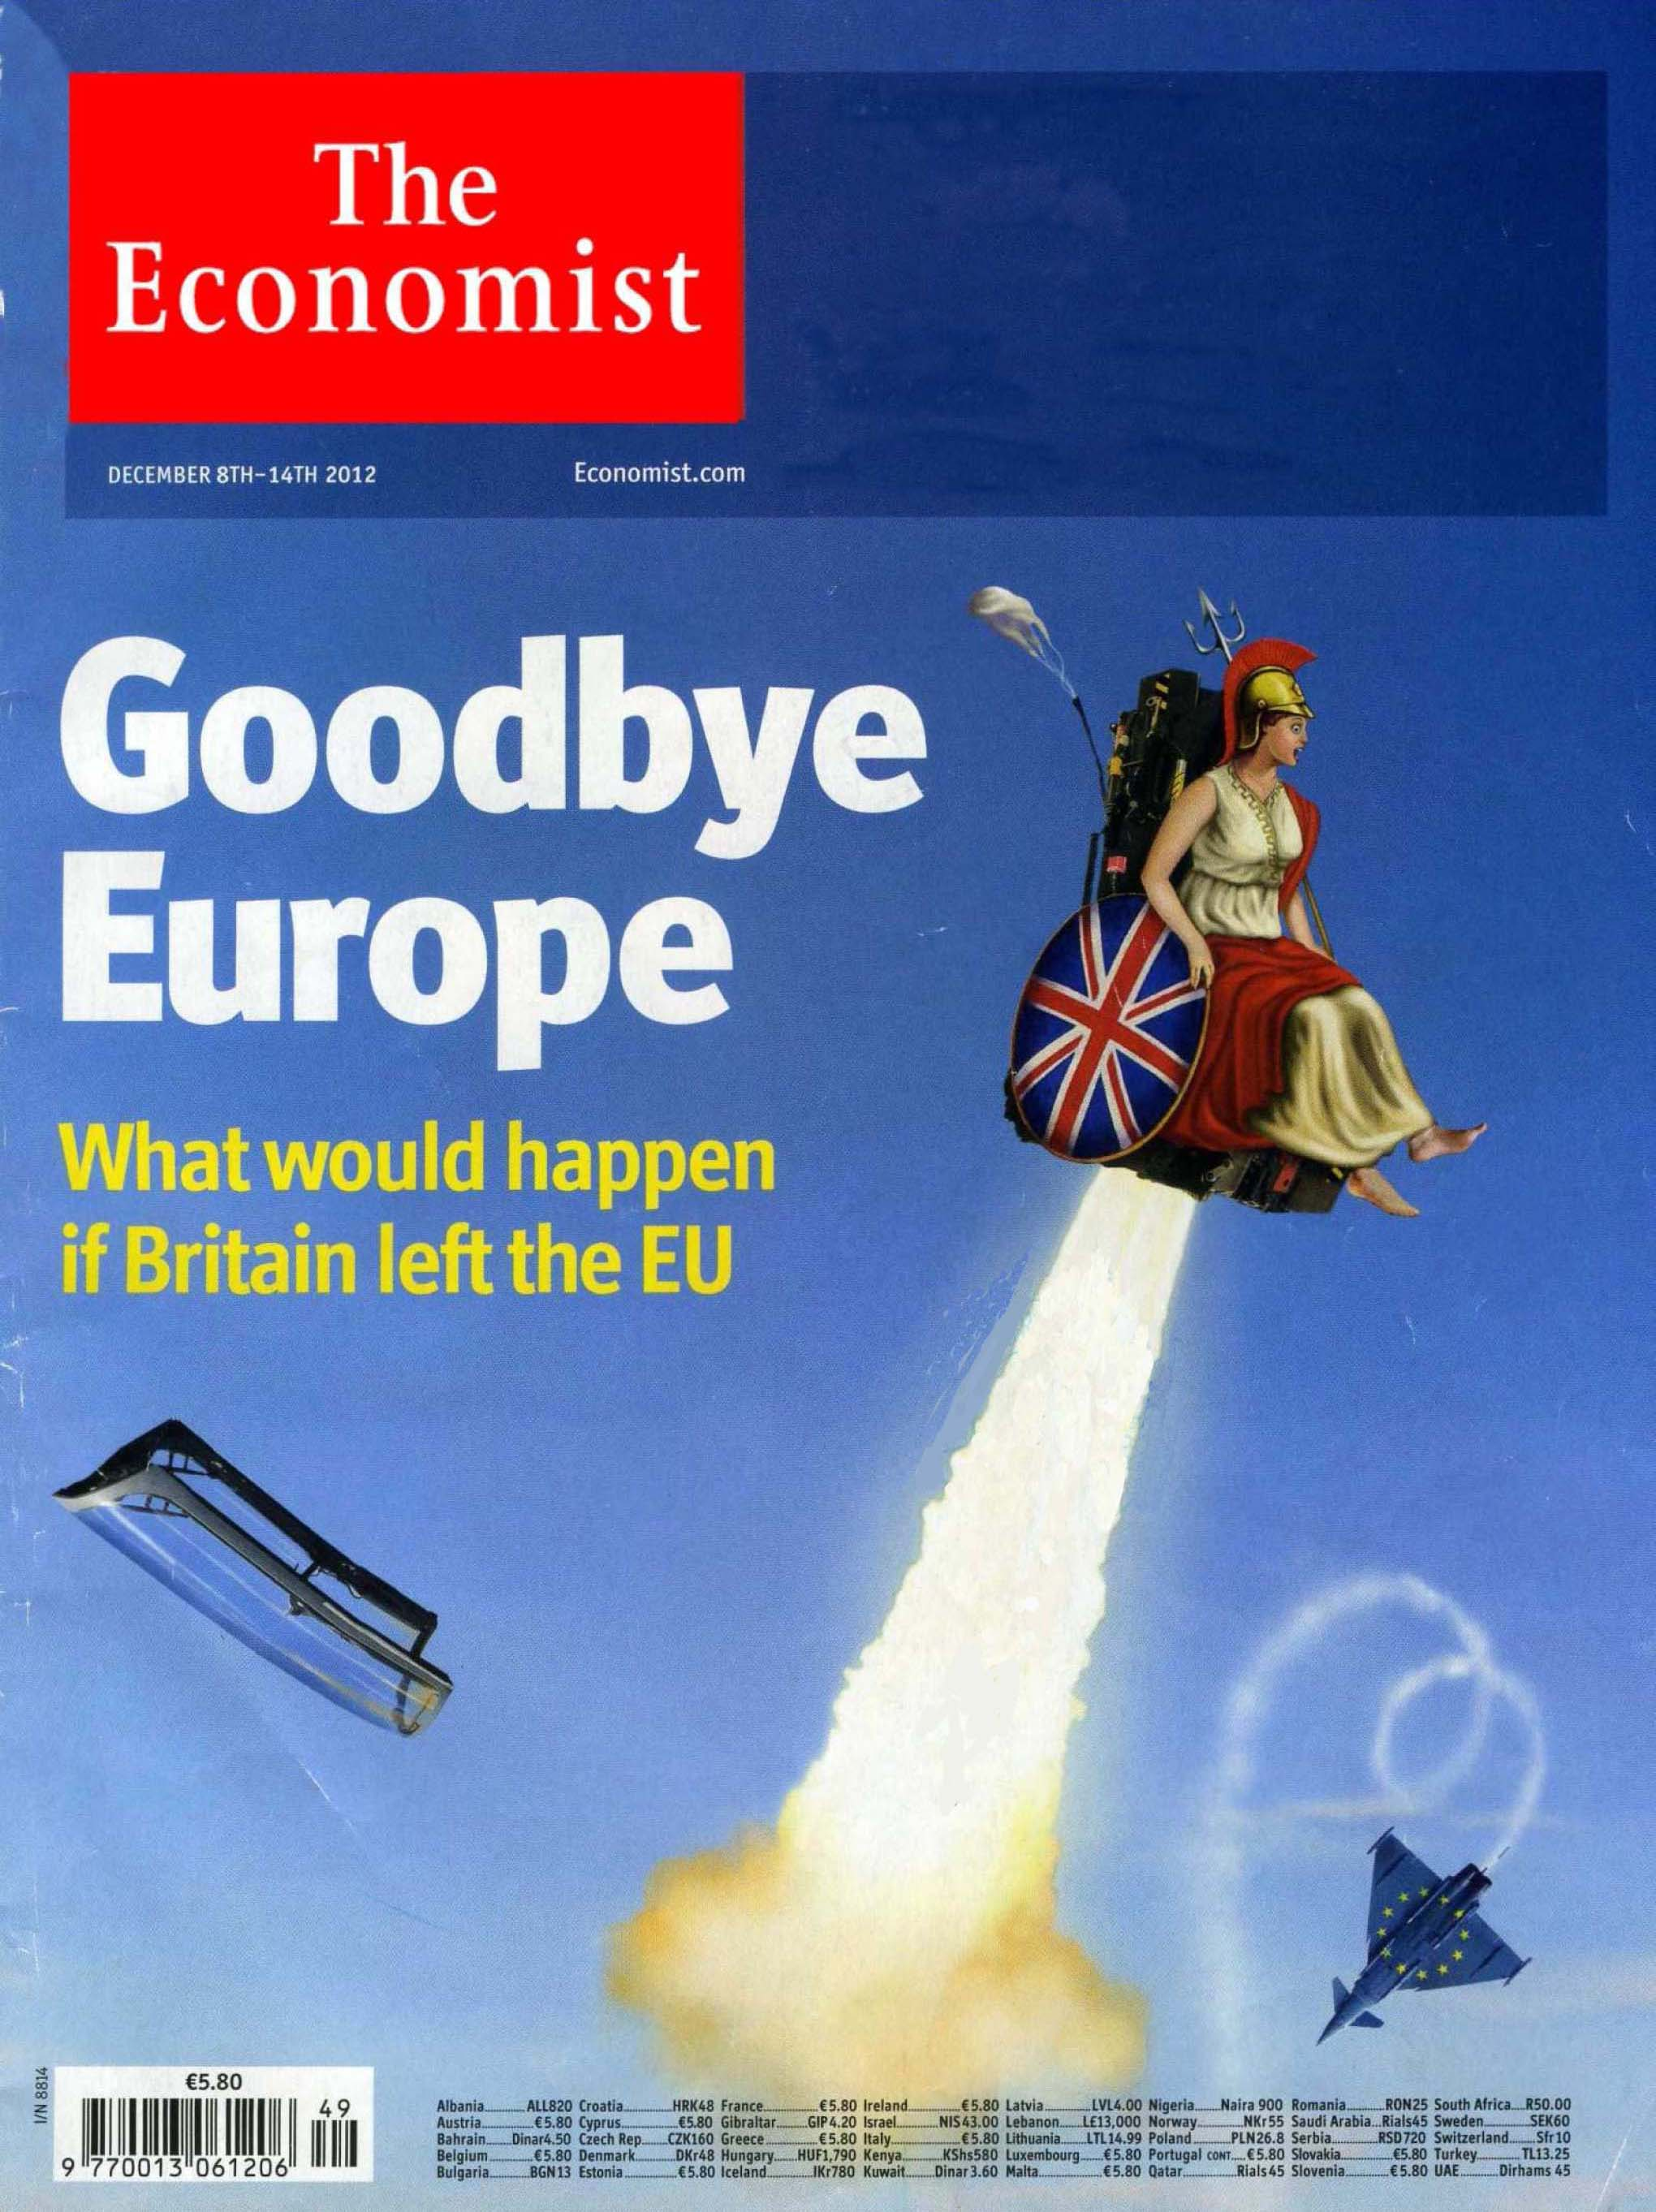

**DOCUMENT 2**

**D**a**vid Cameron: We must stop the “bossiness of Brussels” but remain in the EU**

Hinting strongly that he will offer a referendum on the UK’s relationship with Europe the Prime Minister said the British people must be involved in a “proper debate” about the EU.

Mr Cameron is preparing to make a speech next week setting out Britain’s relationship with the EU and is expected to promise a future referendum.

He is expected to set out plans to repatriate some powers from Brussels to Britain – and then give the public a vote on whether they back the new relationship. […]

Despite saying he believes Britain is “better off” in the EU, the Prime Minister sharply criticized Brussels.

“There’s too much interference, too much bossiness from Brussels and we need to deal with that,” the Prime Minister added.

“[We need to] make sure powers can flow backwards as well as the other direction. People want that fixed and they want to have more of a say and we should not be frightened of involving the British people in a proper debate about Europe and that is what I’m doing.”

Mr Cameron emphasized that he is “not happy” with the EU and that powers must be repatriated if the UK is going to remain a member.

**Abridged from *telegraph.co.uk*, January 14th, 2013**

**DOCUMENT 3**

**Making the break**

[…] If Britain walked away entirely – the most extreme scenario – it would quickly see some benefits. The country would no longer have to transfer funds to the EU to subsidize farm incomes or poorer regions. Treasury suggests it would be £8 billion ($13 billion) better off each year.

Some irksome regulations could be ditched too. First to go (if the Tories are in power when Britain leaves) would be the working-time directive. This limits how long people can be at work without a break or a holiday and caps the week at 48 hours. The scrapping of the EU’s agency-worker directive, which gives temporary staff the same rights as regular employees, would be cheered by business, too. Britain would be free to set itself a less exacting target for green-power generation than it is bound to under the EU’s renewable-energy directive. That could mean cheaper power. […]

Product regulations would be harder to junk than labour laws. The British suppliers to Airbus, the Franco-German aircraft manufacturer have to comply with exacting standards. But these exist not because of meddling by Brussels, but to ensure aircraft are safe. Similarly, a minimum standard of food safety stops a race to the bottom by competing firms. British ones would still have to observe Europe’s product regulations to export there. […] And some immediate gains would evaporate. […] British farmers would lose £2.7 billion in EU subsidies once Britain left. […]

If the benefits of leaving the single market are qualified, what of the costs? […] The impact on industries such as food and textiles, where tariffs are much higher than the average, would be far from mild. British dairy exports would incur an import tax of 55% to reach the EU market, with tariffs on some items of more than 200%. […] Average tariffs on clothing would push up their price in European markets by 12%.

Parts of Britain’s car industry would move out. British-based producers would face a 4% tariff on car-equipment sales to the EU, and there would be pressure to impose tariffs on components imported from it. […]

Aerospace is another industry that relies on frictionless trade with the rest of the Continent. Britain has the world’s largest industry outside America, but it would lose ground to France. […] Big manufacturers like Airbus prefer to keep supply chains simple. They might sponsor entry by new suppliers in the EU to avoid a customs barrier.

[…] The most likely outcome would be that Britain would find itself as a scratchy outsider with somewhat limited access to the market, almost no influence and few friends.

**Abridged from *The Economist*, December 8th, 2012**

**DOCUMENT 4**

**What’s the EU ever done for us? This lot…**

At last we may get a debate on Britain's relationship with Europe. What did the EEC/EU ever do for us? Not much, apart from: providing 57% of our trade; structural funding to areas hit by industrial decline; clean beaches and rivers; cleaner air; lead free petrol; restrictions on landfill dumping; a recycling culture; […] improved consumer protection and food labeling; a ban on growth hormones and other harmful food additives; […] no paperwork or customs for exports throughout the single market; […] freedom to travel, live and work across Europe; […] labour protection and enhanced social welfare; smoke-free workplaces; equal pay legislation; holiday entitlement; the right not to work more than a 48-hour week without overtime. […]

All of this is nothing compared with its greatest achievements: the EU has for 60 years been the foundation of peace between European neighbours after centuries of bloodshed. It furthermore assisted the extraordinary political, social and economic transformation of 13 former dictatorships, now EU members, since 1980. […] We in the UK should reflect on whether our net contribution of £7bn out of total government expenditure of £695bn is good value. We must play a full part in enabling the union to be a force for good in a multipolar global future.

**Abridged from a text by Simon Sweeney,**

**published in the Letters section of *guardian.co.uk*, January 11th, 2013**

**TRAVAIL À FAIRE PAR LE CANDIDAT**

Le dossier qui vous est proposé comporte **4** documents :

**Document** **1** **:** la couverture de *The Economist* du 8-14 décembre 2012 et son titre *Goodbye Europe – What would happen if Britain left the EU*

**Document** **2** **:** un article du site *telegraph.co.uk* du 14 janvier 2013, intitulé *David Cameron: We must stop the “bossiness of Brussels” but remain in the EU*

**Document** **3** **:** un article de *The Economist* du 8-14 décembre 2012, intitulé *Making the break*

**Document** **4** **:** une lettre d’un universitaire britannique publié sur le site *guardian.co.uk*, datée du 11 janvier 2013, intitulée *What’s the EU ever done for us? This lot…*

**I – COMPRÉHENSION (10 points)**

En vous appuyant sur les quatre documents fournis, vous rédigerez en français une note de 250 mots (+/-10%) qui rendra compte des problématiques présentes dans ce dossier.

Vous indiquerez le nombre de mots utilisés.

**II – EXPRESSION EN LANGUE ANGLAISE (10 points)**

1. Answer the question below (150 words +/-10%).

According to you, what is the position of *The Economist* on the issue represented on the cover? (document 1).

Specify the number of words used.

1. Vous vous appelez Laura James, chef d’entreprise d’une société britannique exportatrice de jeux vidéo à travers toute l’Europe.

Vous écrivez à l’organisation patronale *CBI* (*Confederation of Business Industry*) afin d’expliquer pourquoi vous souhaitez que le Royaume-Uni reste membre de l’Union Européenne. Vous décrivez les atouts qu’elle représente au quotidien pour votre entreprise et vous les alertez des conséquences d’une éventuelle sortie de l’UE. Vous demandez au CBI de se faire l’écho de vos préoccupations auprès du gouvernement britannique.

Formules et présentation d’usage.

(150 mots +/-10% : corps du courrier sans les éléments périphériques)

Vous indiquerez le nombre de mots utilisés.